LEAN Facilities O & M Planning:
Strategy, Objectives, & Methods – 2018 and Beyond
by Peter Cholakis
Four BT, LLC
www.4BT.US

Contents
Introduction 2
Application 5
Organizational Strategy, Goals, Required Outcomes 5
Budgeting/Capital Planning Considerations 7
LEAN Business Models and Methods 8
Multiple Competencies, Business Processes, and Activities 12
Supporting Technologies and Tools 13
Education, Training, and Support Services 14
Metrics/Key Performance Indicators (KPIs) 15
Challenges and Obstacles 17
Lessons Learned 17
Relevant Codes and Standards 18
Key Terms & Defintions 18
Resources 20

Introduction

LEAN Facilities O & M Planning greatly aids in improving facilities operations and maintenance (O & M) outcomes. Over 90% of projects can be consistently delivered on-demand, on-time, on-budget, and to everyone’s satisfaction. Furthermore, a significantly higher percentage of budgets are spent upon planned versus unplanned/emergency activities. These positive results are achieved through the implementation LEAN processes that have been proven over the past thirty years.

LEAN O & M integrated service delivery planning leverages the experience, considerations, and input of facilities management (FM) teams, external service providers (AE’s, construction contractors…), and building users throughout the facility life-cycle, from early concept development through final deconstruction/recycling.
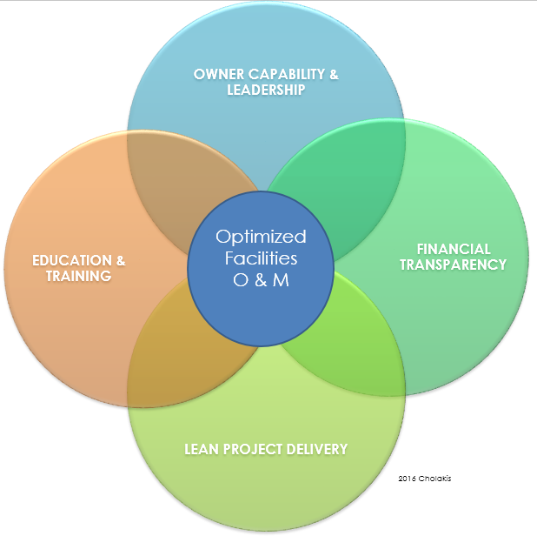

A core requirement and benefit of current, standardized, and actionable information, a common data environment (CDE). A CDE consists of a shared glossary of terms, definitions, and standardized data formats/data architectures. Terms, definitions, and tasks must be in plain English without the excessive use of confusing acronyms. For example, each task should be represented with a full description of activities and any details associated with labor, material, and equipment costs. Examples of standard data architectures include CSI Uniformat, MasterFormat, Omniclass, Cobie, etc.
Appropriate education, experience, and ongoing training is also needed in order for O & M personnel to effectively interact with internal and external stakeholders/service providers.

With respect to training, it is important to recognize that facilities O & M management is directly and indirectly linked to, supported by, and integrated with, a diverse array of business processes, competencies, activities, and processes throughout the life-cycle management of a built structure. These inter-related domains and their relationships are an illustrated in the following graphic.

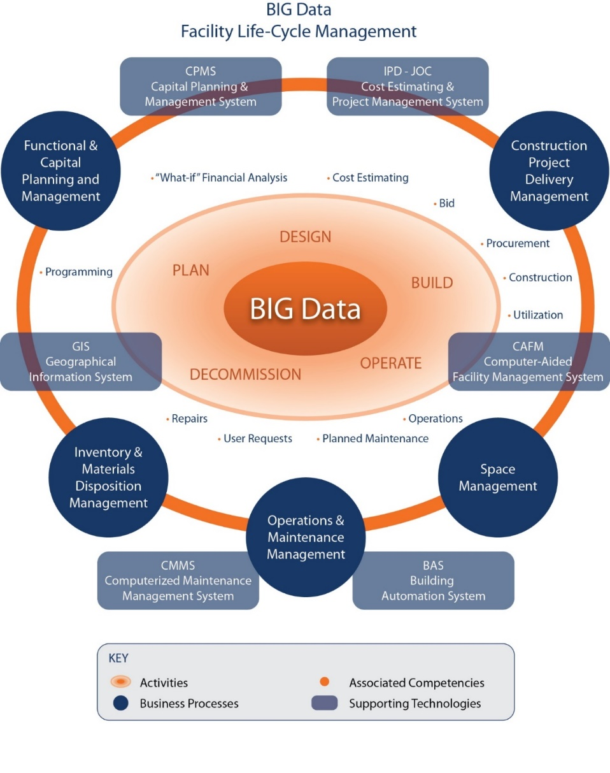

O & M planning and execution requires consideration of the following;
- LEAN processes,
- resource requirements with respect to budgetary, personnel, technical services and tools, detailed written execution/operations manuals, and
- key performance indicators (KPIs) and metrics to monitor program success.

Another noteworthy element is a detailed written Facilities O & M Manual (also called an O & M Execution Guide). Participant and stakeholder roles, responsibilities, workflows, documentation, and deliverables are clearly documented and may be updated as needed.

Specific examples of LEAN integrated service delivery methods/integrated construction delivery methods include Integrated Project Delivery (IPD) and Job Order Contracting (JOC).

Adoption of these highly efficient methods does however is generally a departure from “traditional” ways of conducting day-to-day activities. Many organizations may therefore require a focus upon “change management” to assure that all stakeholders and participants are “on board” and capable of working within these new approaches.

Note: Improving operations and maintenance outcomes has come to the forefront due to environmental and economic landscape challenges and imperatives. These include the shrinking availability of natural resources, global climate change, and increasingly competitive economic markets. All of which combine to demand greater focus upon productivity and measurable gains in improved resource utilization.

Application
Facilities O & M Management considerations span several areas. A partial list is shown below:
- Organizational Strategy, Goals, Required Outcomes
- Budgeting/Capital Planning
- LEAN Business Models and Methods
- Multiple Competencies, Business Processes, and Activities
- Supporting Technologies and Tools
- Education, Training, and Support Services
- Metrics/Key Performance Indicators (KPIs)
- Common Data Environment (CDE)

Organizational Strategy, Goals, Required Outcomes
The full support of an organization and associated service providers is required in order to deliver provide a level facilities operations and maintenance that optimally supports organizational goals.

A comprehensive written facilities management operations and maintenance manual and/or execution guide is a fundamental requirement. It should be written with LEAN process fundamentals in mind that focus upon BEST VALUE outline measurable desired OUTCOMES.
Appropriate and ongoing consideration of PEOPLE, PROCESS, INFORMATION, and TECHNOLOGY is needed during the development of the Operations Manual / Execution Plan.
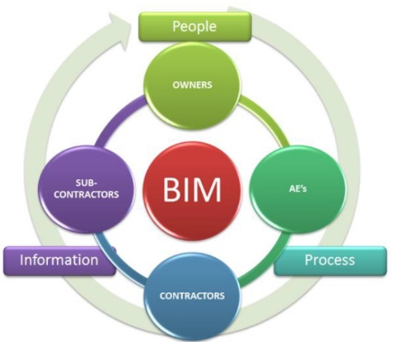

Budgeting/Capital Planning Considerations
Post-construction costs average 80% of total facilities investment over time. Thus, emphasis upon O &M budgeting and capital planning provides major benefits.

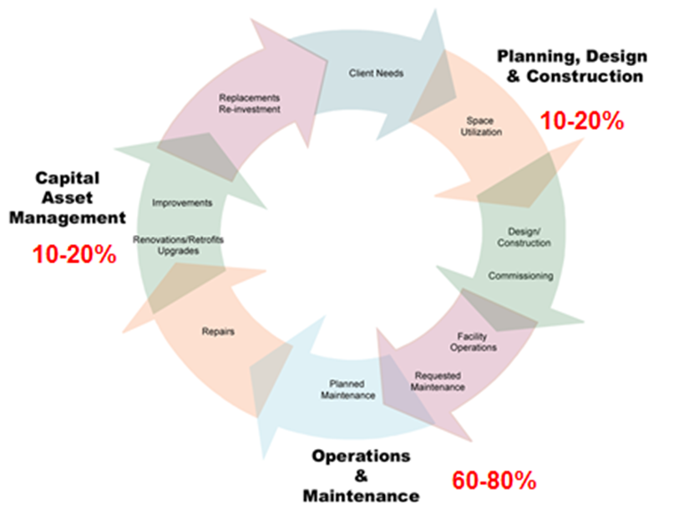

Most organizations are historically first-cost driven, a bias that negatively affects overall return on investment and appropriate facilities stewardship. Decision-support tools and services (technology, data, and consulting/education/support) enable consideration of current needs as well as life-cycle costs and prioritization.
A life-cycle approach to facilities capital reinvestment facilities provides the highest likelihood of positive overall results, while no doing so can have serve negative consequences.

Many organizations spend up to 80% of operations and maintenance funds on emergency, unplanned projects and/or projects that provide relatively little value to an organization.

With proper planning and management processes in place, this ratio can be reversed. This beneficial “shift” in resource allocation however is impossible without current actionable information, appropriate decision-support tools and appropriate strategies among all participants and stakeholders.

LEAN Business Models and Methods
The productivity, quality, value and satisfaction associated with any facility renovation, repair, maintenance, sustainability, or new construction project are directly linked to the processes employed. Promoting awareness and education of LEAN construction practices and associated construction delivery methods among Owners, Contractors, Engineers, Architects, and Oversight Groups are the first steps towards efficient management of the built environment.

Within the LEAN Construction / Collaborative Construction Delivery process framework, emphasis is upon BEST VALUE OUTCOMES as the can be achieved through the leveraging of expertise of all project participants and stakeholders from initial concept and throughout the entire life-cycle of the built structures.

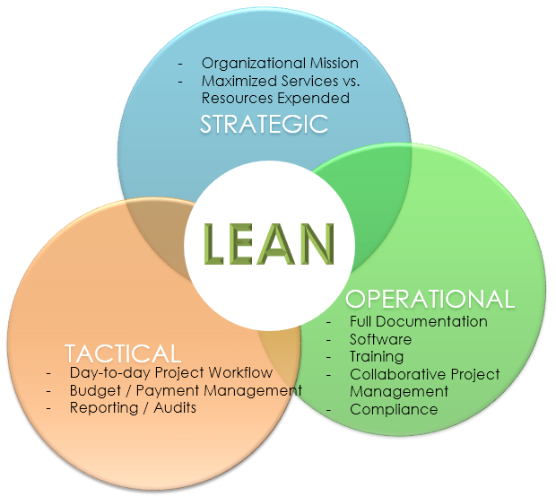
A common body of knowledge and an associate standard of excellence are tools that assist in reversing waste, and other negative economic and environmental issues common to the Architecture, Engineering, Construction, Operations, Owner (AECOO) and Facilities Management sectors.

LEAN, BEST VALUE CONSTRUCTION DELIVERY METHODS have been available for decades, but only practiced by fractional percentage of Real Property Owners and service providers. The reason for limited adoption of these methods, capable of enabling more projects to be completed on-time and on-budget, and with higher levels of quality and satisfaction, is simple: A sector-wide lack of awareness and education and common cultural barriers.

The most widely used collaborative construction delivery methods are JOB ORDER CONTRACTING, JOC for renovation, repair, and maintenance activities and INTEGRATED PROJECT DELIVERY, IPD for major new construction.
JOC, a form of IPD, is directly applicable to operations and maintenance. A typical workflow for a JOC project is shown below.
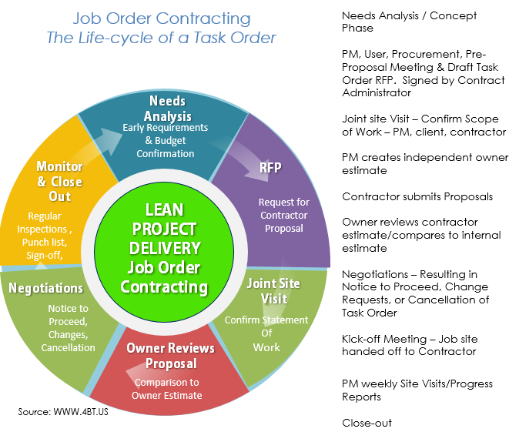
LEAN Construction methods share has the following characteristics;
- Performance-based reward based upon achievement of specified goals.
- Defined work flows, data formats, and technologies which enable experiences with the principles and techniques of state of work definition, cost estimating, project management, and performance analysis to be reported, discussed, documented, and reused.
- Required initial and ongoing training
- Systems to maintain standards of proficiency and performance
- Required collaboration among internal and external project participants with common or related purposes, in furtherance of project success
- Clear and transparent mechanisms for all participants to collectively discuss and comment on subjects of common interest
- Common and shared standards for terminology, definitions, conduct and application of all procedures and policies
- Shared risk/reward
- Mutual respect
- Continuous improvement

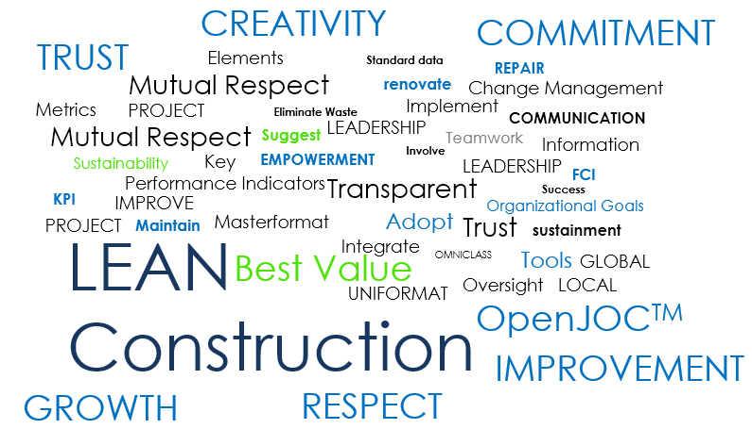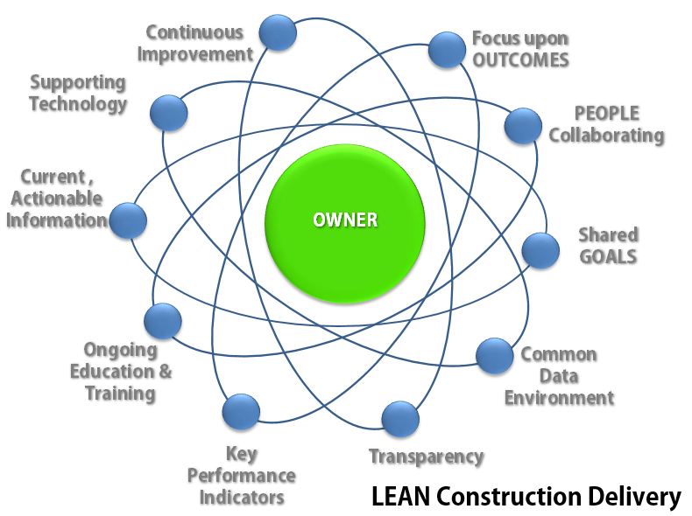

Multiple Competencies, Business Processes, and Activities
Facilities O & M management spans multiple competencies (core skills), business process (asset management practices/industries), and activities. A partial listing is shown below with links to additional information.

Competencies/Activities
  - Strategic planning
  - Cost estimating
  - Procurement/bidding
  - Construction
  - Space planning
  - Operations
  - Planned, unplanned, user requested maintenance
  - Repairs, improvements/upgrades, retrofits, replacements
  - Programming

Business Processes
  - Capital planning and management
  - Construction project delivery methodology
  - Space management
  - Operations and maintenance
  - Inventory and maintenance disposition management

Supporting Technologies and Tools
Multiple technologies and tools can be used to lower the cost of establishing and deploying facilities management operations and management best practices consistently. A partial listing is shown below, with appropriate links to additional information where available.

Technologies
Application Software
- Building Automation Systems (BAS)
- Building Information Modeling, Model, and Management Systems (BIM)
- Capital Planning and Management Systems (CPMS)
- Computer-aided Facilities Management Systems (CAFM)
- Computerized Maintenance Management Systems (CMMS)
- Cost Estimating, Procurement, & Construction Project Delivery and Management Systems
- Geographical Information Systems (GIS)
- Integrated Workplace Management Systems (IWMS)

Tools
- Construction code databases
- Construction cost databases
- Data formats: PDF, Graphics (2D, 3D, PNG, JPG, …)
- Industry specific glossaries
- Industry Standards (ISO, NIST)
- O & M Execution Guide
- O & M Manuals
- Standardized data architectures (Cobie, Masterformat, Uniformat, Omniclass)
- Technical construction specification

Education, Training, and Support Services
Enhancing the understanding and appreciation specifically within the below areas will aid in improving productivity, quality, and satisfaction across the AECOO sector, thereby bringing facilities management operations and maintenance to a higher level of performance:
- Collaborative methods
- Leadership without excessive management
- Linking global oversight with local knowledge and execution
- Life-cycle / total cost of ownership management techniques
Training and education must be required and ongoing for all stakeholders.

Metrics/Key Performance Indicators (KPIs)
Ongoing performance measurement supports informed, information-based, decision making and improve resource allocation targeting facilities operations and maintenance.
From a generic perspective, an effective measurement system includes:
- Clearly defined, actionable, and measurable goals.
- Key performance indicators that monitor the overall administration of O & M program, as well as individual projects / task orders, and all associated workflows, deliverables, and outcomes.
- Established baselines enabling measurement of historical and current progress.
- A basis of timely, accurate, repeatable, and verifiable information based upon standardized terms, definitions, and data architectures
- Applicable reporting and feedback systems to support continuous improvement of processes, practices, and outcomes.
- Leading Indicators (forecast future trends inside and outside the organization) as well as lagging indicators
- Objective and unbiased information (not subject to manipulation) that is normalized (can be benchmarked against other organizations, departments, locations)
- Statistically reliable
- Unobtrusive (not disruptive of work or trust)
- Appropriate (measures the right things)
- Quantifiable
- Verifiable/auditable.
The importance of performance measurement cannot be understated. It is a fundamental element of LEAN management practices.
Sample O & M performance indicators:
- Annualized Total Cost of Ownership (TCO) per building per gross area = Rate per square foot
- Annualized TCO per building/Current replacement value = Percent of Current Replacement Value (CRV)
- Annualized TCO per building/Net assignable square feet = Cost rate per net assignable square feet per building
- Annualized TCO per building/Non-assignable square feet = Cost rate per non-assignable square feet per building
- Annualized TCO per building/Building Interior square feet = Cost rate per interior square foot per building
- Churn Rate
- Utilization Rate
- AI (Adaptation Index) or PI (Programmatic Index) = PR (Program Requirements)/CRV (Current Replacement Value)
- Uptime or Downtime = Defined in percent, as amount of time asset is suitable for the program(s) served.
- Facility Operating Gross Square Foot (GSF) Index (SAM Performance Indicator: APPA 2003)
- Custodial Costs per square foot
- Grounds Keeping Costs per square foot
- Energy Usage is expressed as a ratio of British Thermal Units (BTUs) for each Gross Square Foot (GSF) of facility, group of facilities, site or portfolio = British Thermal Units BTUs / Gross Area GSF
- Utility Costs per square foot
- Waste Removal Costs per square foot
- Facility Operating Current Replacement Value (CRV) Index = Facility Operating CRV Index = Annual Facility Maintenance Operating Expenditures ($)/Current Replacement Value ($) (SAM Performance Indicator: APPA 2003)
- Facility Operating GSF Index = Annual Facility Maintenance Operating Expenditures ($)/Gross Area (GSF)
- Planned/Preventive Maintenance Costs per square foot
- Emergency Maintenance Costs as a percentage of Annual Operations Expenditures.
- Unscheduled/Unplanned Maintenance Costs as a percentage of Annual Operations Expenditures.
- Repair costs (man hours and materials) as a percentage of Annual Operations Expenditures
- FCI (Facility Condition Index) = DM (Deferred Maintenance) + CR (Capital Renewal)/CRV (Current Replacement Value)
- Recapitalization Rate, Reinvestment Rate
- Deferred Maintenance Backlog
- Facilities Deterioration Rate
- AI (Adaptive Index) or PI (Programmatic Index) = PR (Program Requirements)/CRV (Current Replacement Value)
- FQI (Facility Quality Index) or Quality Index or Index = FCI (Facility Condition Index) + AI (Adaptive Index)
- Capital Renewal Index = Annual Capital Renewal and Renovation/Modernization Expenditure ($)/Current Replacement Value ($) EMERGING Issues

Challenges and Obstacles
The primary challenge to real property owners and service provides is the integration O & M throughout all phases of the life-cycle of a built structure. The level of collaboration and transparency required demands a change in way most organizations operate on a day to day business. In addition to improving technical competence in associated means and methods, significant effort should also be placed upon CHANGE MANAGEMENT in order to better assure attainment of desired outcomes.

Lessons Learned
Facilities O & M management differs from many other areas in that it is ongoing and can transcend generations. Furthermore, the impact of new strategies and processes can take years to show measurable improvements. Within a society that seeks instant gratification and financial payback periods sometimes measure in months versus years, the need for leadership and commitment of property owner management is paramount.
Additionally, the fractured and typically non-collaborative nature of the AECOO sector further complicates successful O & M strategy implementation. As note previously, Owners, Architectures, Engineers, Contractors, and Building Users are just a few of the stakeholder that must work together to ensure an efficient strategic and tactical O & M program.
With respect to technology. A somewhat common pitfall of many is the assumption that technology is a solution. Technology plays a major role in enablement, but the solution can only be found within collaborative business process deployment and continuous improvement.

Relevant Codes and Standards

Key Terms & Defintions
Operations All activities associated with the routine, day to day use, support and maintenance of a building or physical asset; inclusive of administration, management fees, normal/routine maintenance, custodial services and cleaning, fire protection services, pest control, snow removal, grounds care, landscaping, environmental operations and record keeping, trash-recycle removal, security services, service contracts, utility charges (electric, gas/oil, water), insurance (fire, liability, operating equipment) and taxes. It does not include capital improvements. This category may include expenditures for service contracts and other third-party costs. Operational activities also involve routine renovation and repair construction work that are incidental to operations but generally do not include individual projects considered to require significant design and/or capital reinvestment above an established threshold.
Normal/Routine Maintenance and Minor Repairs Cyclical, planned work activities funded through the annual budget cycle, done to continue or achieve either the originally anticipated life of a fixed asset (i.e., buildings and fixed equipment), or an established suitable level of performance. Normal/routine maintenance is performed on capital assets such as buildings and fixed equipment to help them reach their originally anticipated life. Deficiency items are low in cost to correct and are normally accomplished as part of the annual operation and maintenance (O&M) funds. Normal/routine maintenance excludes activities that expand the capacity of an asset, or otherwise upgrade the asset to serve needs greater than, or different from those originally intended.
Predictive Maintenance/Testing/Inspection Routine maintenance, testing, or inspection performed to anticipate failure using specific methods and equipment, such as vibration analysis, thermographs, x-ray or acoustic systems to aid in determining future maintenance needs. For example, tests to locate thinning piping, fractures or excessive vibration that are indicative of maintenance requirements.
Planned or Programmed Maintenance Includes those maintenance tasks whose cycle exceeds one year. Examples of planned or programmed maintenance are painting, flood coating of roofs, overlays and seal coating of roads and parking lots, pigging of constricted utility lines and similar functions.
Preventive Maintenance A planned, controlled program of periodic inspection, adjustment, cleaning, lubrication and/or selective parts replacement of components, and minor repair, as well as performance testing and analysis intended to maximize the reliability, performance, and lifecycle of building systems, equipment, etc. Preventive maintenance consists of many check point activities on items that if disabled, may interfere with an essential installation operation, endanger life or property, or involve high cost or long lead time for replacement.
Emergency Maintenance Unscheduled work that requires immediate action to restore services, to remove problems that could interrupt activities, or to protect life and property. Unscheduled/Unplanned Maintenance Reactive and non-emergency corrective work activities that occur in the current budget cycle or annual program. Activities may range from unplanned maintenance of a nuisance nature requiring low levels of skill for correction, to non-emergency tasks involving a moderate to major repair or correction requiring skilled labor.
Repair(s) Work that is performed to return equipment to service after a failure, or to make its operation more efficient. The restoration of a facility or component thereof to such condition that it may be effectively utilized for its designated purposes by overhaul, reprocessing, or replacement of constituent parts or materials that have deteriorated by action of the elements or usage and have not been corrected through maintenance.
Routine Repairs Actions taken to restore a system or piece of equipment to its original capacity, efficiency or capability. Routine repairs are not intended to increase significantly the capacity of the item involved. For example, the replacement of a failed boiler with a new unit of similar capacity would be a routine repair project. However, if the capacity of the new unit were double the capacity of the original unit, the cost of the extra capacity would have to be capitalized and would not be considered routine repair work.
Emergency Repairs Requests for system or equipment repairs that are unscheduled and unanticipated. Service calls generally are received when a system or component has failed and/or perceived to be working improperly. If the problem has created a hazard or involves an essential service, an emergency response may be necessary. Conversely, if the problem is not critical, a routine response is adequate.
Unscheduled/Unplanned Maintenance Requests for system or equipment repairs that - unlike preventive maintenance work - are unscheduled and unanticipated. Service calls generally are received when a system or component has failed and/or perceived to be working improperly. If the problem has created a hazard or involves an essential service, an emergency response may be necessary. Conversely, if the problem is not critical, a routine response is adequate. Reactive and/or emergency corrective work activities that occur in the current budget cycle or annual program. Activities may range from unplanned maintenance of a nuisance nature requiring low levels of skill for correction, to non-emergency tasks involving a moderate to major repair or correction requiring skilled labor, to emergency unscheduled work that requires immediate action to restore services, to remove problems that could interrupt activities, or to protect life and property.
Programmed Major Maintenance: Includes those maintenance tasks whose cycle exceeds one year. Examples of programmed major maintenance are painting, roof maintenance, (flood coating), road and parking lot maintenance (overlays and seal coating), utility system maintenance (pigging of constricted lines) and similar functions.

Resources
Amaratunga D, Baldry D and Sarshar M (2000) “Assessment of facilities management performance – what next?” Facilities 18(1/2): 66-75.
Chan A P C and Chan A P L (2004) “Key performance indicators for measuring construction success” Benchmarking: An International Journal 11(2): 203-221.
Mudrak, T., Wagenberg, A.V. and Wubben, E. (2004), "Assessing the innovative ability of FM teams: a review", Facilities, Vol. 22 Nos 11/12, pp. 290–5.
John H. Cable, Jocelyn S. Davis, Federal Facilities Council Ad Hoc, Committee on Performance Indicators for Federal Real Property Asset Management Federal Facilities Council Technical Report #147, KEY PERFORMANCE INDICATORS FOR FEDERAL FACILITIES PORTFOLIOSTHE NATIONAL ACADEMIES PRESS, Washington, D.C.
Capital Asset Management, TOOLS AND STRATEGIES FOR DECISION MAKING, CONFERENCE PROCEEDINGSFEDERAL FACILITIES COUNCIL TECHNICAL REPORT No. 143, 2001
www.nap.edu
ISO/TC 267 Facility management
ISO 41001, Facilities management – Management systems

The term “facilities” is being used to represent any type of built structure, including but not limited to buildings, roads, dams, bridges, airports/mass transit, utilities, etc.
The construction project delivery method, or project delivery method is the process established to define, cost, procure, execute, and manage) O & M and other construction/service tasks. As there are numerous and disparate operations and
AECOO-Architecture, Engineering, Construction, Operations, Owner

